(Service Registry) Eureka Naming Server:



1) Add Eureka-Server Dependency   
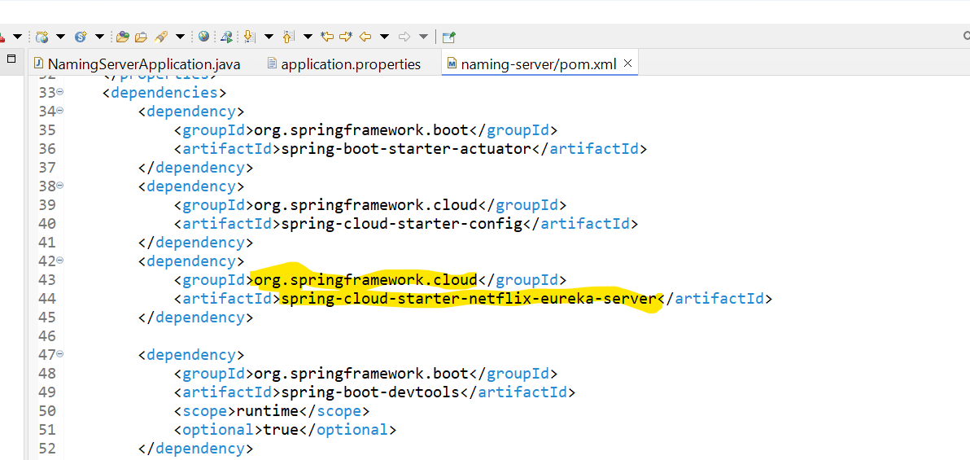

2) Controller add annotation **@EnableEurekaServer**

3) application.properties configuration

